

Trendr

CS40700 Design Document

1.23.23

Our team:

Jake Baker

Logan Sweeney

Alan Bare

Jack Lawrence

Shicheng Fang

Daniel Fruland

Table of Contents

1. Purpose
2. Design Outline
3. Design Issues
4. Design Details

**1. Purpose**

Trendr is designed for users to be able to view a different kind of metric for stocks they have interest in. By scraping data from Facebook, Twitter, and Reddit posts, Trendr seeks to establish a measurable statistic on how much attention and positivity a stock is getting. Attention is a measurement of overall frequency of the mentioning of a stock. Positivity refers to the words mentioned in tandem with the stock, if the words are generally positive the stock will have a higher positivity score. The combination of both positivity and attention scores gives us a new metric; the Trendr score. A higher score would indicate that a stock is potentially on the rise and users should continue to invest, whereas a decreasing score would imply that users may want to think twice before investing or sell before the price of the stock drops.

Although account creation is not necessary to view the Trendr score of stocks, creating an account allows a user to store which stocks they would like to have tracked on their Trendr homepage. Users can also share their account and individual stocks with other users; creating a network of Trendr accounts similar to a collaborative stock brokerage. Although competitors offer similar services for tracking the social media attention stocks are getting, Trendr seeks to provide a non-biased account of the attention alongside quick and free score fetching.

**2. Design Outline**

The structure of Trendr falls under the Client-Server model. Our central server (hosted through Azure) will handle multiple client connections simultaneously. We will also have a module for handling score fetching requests whenever a stock new to our system is requested for tracking. Currently tracked stocks will update their info on a regular interval. The server will be tasked with handling the refreshing of current stock’s Trendr scores as well as fetching any necessary data that may need to be fed back to the client.

1. **Client**
2. The client will allow the user to interact directly with Trendr’s functionality.
3. The client will make requests to the fetch module whenever a stock new to Trendr is tracked by the user.
4. The client will have a comprehensive UI that allows users to track stocks, view tracked stocks, and customize their experience.
5. **Server**
6. The server will handle all interactions between client requests and the database.
7. The server will receive new stocks from the module and any other client-requested information from the database.
8. The server will send client information (username, password, phone number) to the database for storage.
9. The server will send new stocks from the module to the database for storage and continued tracking.
10. **New Stock Fetch Module**
11. The New Stock Fetch Module (NSFM) will handle requests from the client to track a stock new to Trendr.
12. The module will establish protocols for the scraping of info for the new stock if possible and send the required information to the server for continued tracking.
13. **Database**
14. Stores user profile information such as name, email, and stocks in their watchlist
15. **External APIs**
    1. Twilio (for SMS MFA codes)
    2. Facebook, Twitter, and Reddit APIs for calculating Trendr score
    3. Finnhub.io API to access stock data (price, daily change, etc)

**2.1 High Level Overview**

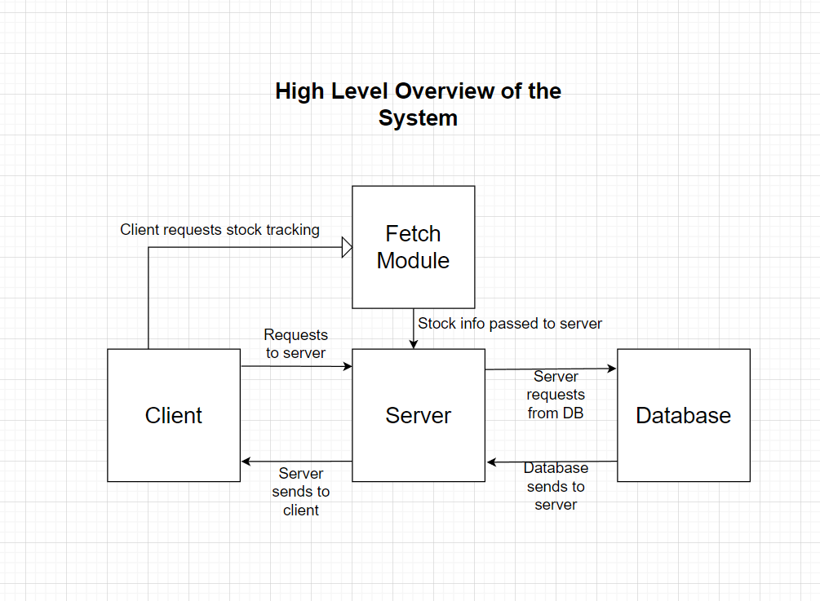

Functional Requirements:

1. As a user, I would like to be able to register specific stocks for tracking.
2. As a user, I would like my chosen stocks to be displayed on the homepage of the site.
3. As a user, I would like to be able to create an account on Trendr with email and password.
4. As a user, I would like to be able to reset my password with Email
5. As a user, I would like to be able to reset my password with SMS
6. As a user, I would like to be able to secure my account with two factor email authorization.
7. As a user, I would like to be able to secure my account with two factor sms authorization.
8. As a user, I would like to edit which stocks I currently am tracking.
9. As a user, I would like to reorganize my front-page by determining a priority order of tracked stocks.
10. As a user, I would like to be able to switch between light and dark mode.
11. As a user, I would like to be able to read a quick summary of how a stock’s Trendr score is determined.
12. As a user, I would like to view the Trendr scores of the stocks I’ve set to be tracked.
13. As a user, I would like to view stocks based on industry (tech, food, etc)
14. As a user, I would like to view the change in a stock’s Trendr score over a specified amount of time.
15. As a user, I would like to view a stock’s individual attention score.
16. As a user, I would like to view the change in stock’s individual attention score over a specified amount of time.
17. As a user, I would like to view a stock’s individual positivity score.
18. As a user, I would like to view the change in stock’s positivity score over a specified amount of time.
19. As a user, I would like to be notified about big changes in Trendr score of my stocks through email.
20. As a user, I would like to be notified about big changes in Trendr score of my stocks through SMS.
21. As a user, I would like to view the highest increases in Trendr scores over all stocks tracked by Trendr.
22. As a user, I would like to view the highest decreases in Trendr scores over all stocks tracked by Trendr.
23. As a user, I would like to view the highest increases in attention score.
24. As a user, I would like to view the highest decreases in attention score.
25. As a user, I would like to track the top 10 crypto investments Trendr score
26. As a user, I would like to view a graph of the Trendr score for each of the top 10 cryptocurrencies
27. As a user, I would like to view graphs generated by Trendr of a specified stock’s change in Trendr score over time.
28. As a user, I would like to be able to zoom into a graph to see smaller timespans of a stock’s Trendr score
29. As a user, I would like to be able to zoom out of a graph to see larger timespans of a stocks Trendr score
30. As a user, I would like to enable and disable SMS and Email notifications for specific tracked stocks.
31. As a user, I would like to be able to export the information from my tracked stocks.
32. As a user, I would like to be able to share a URL to a specified stock’s Trendr page.
33. As a user, I would like to view a stock’s individual Facebook Trendr score.
34. As a user, I would like to view a stock’s individual Twitter Trendr score.
35. As a user, I would like to view a stock’s individual Reddit Trendr score.
36. As a user, I would like to view a sample of a popular post for a given stock (and whether it was classified as negative or positive).
37. As a user, I would like to be able to click the popular post and be redirected to the source of the post (Twitter, Facebook, or Reddit).
38. As a user, I would like to view percentage change in a stock’s Trendr score.
39. As a user, I would like to upload a csv of my portfolio’s stock positions (sourced from a brokerage such as Schwab, Fidelity, etc) to automatically populate my watchlist.
40. As a user, I would like to be able to remove a stock from my watchlist.
41. As a user, I would like to see the current price of a given stock.
42. As a user, I would like to see the day gain/loss of a given stock.
43. As a user, I would like to see the day’s price chart for a given stock.
44. As a user, I would like to see the current price of all of the stocks in my watchlist displayed on the dashboard.
45. As a user, I would like to see the day gain/loss of all of the stocks in my watchlist displayed on the dashboard.
46. As a user, I would like to be able to add friends
47. As a user, I would like to be able to remove friends
48. As a user, I would like to share my portfolio of tracked stocks with a generated URL.
49. As a user, I would like to be able to see the stocks my friends are interested in
50. As a user, I would like to be able to add a profile picture.
51. As a user, I would like to add a bio to my profile so others can learn more about me.
52. As a user, I would like to create multiple watchlists.
53. As a user, I would like to name my watchlists.
54. As a user, I would like to be able to make a watchlist private or visible to my friends.

Non-Functional Requirements:

**Response Time**

Updates from the server should be processed in real time without having to refresh the app. Under normal internet conditions, responses from the server with graphing information, Trendr Scores, and stock/crypto updates should take less than 500 ms.

**Scalability**

Server loads should be managed quickly by a server that can scale up in the future. Initially, our web app should be able to support 100 users simultaneously with no visible interference in performance.

**User Experience**

The User Interface should be easy and simple to use. The interface will use basic UX design principles. The app will be consistent and easy to learn, as well as be accessible for all types of users: beginners to stock experts.

**Security**

Sensitive user data including password and certain portfolio information should be protected from 3rd party access.

**3. Potential Issues**

Functional issues:

1. How should users log in to their account?
   1. Anonymously, generated ID
   2. **Email and Password**
   3. **Phone Number and Password**
   4. Username and Password
   5. Google Authenticate

**Justification:** Using an email/phone number and password authentication is easy on the users as it does not require them to memorize a randomly-generated ID for login.

1. How can users navigate the website?
   1. **Tabs on top of the page, each with own portions of website to navigate to**
   2. One page, scrollable widgets separated by stock categories we create
   3. One page, tabs are organized with picture representations of stock categories, search bar at the top

**Justification:** If the website were to be one page, it would likely become quite cluttered with information and widgets and not be very user-friendly. Additionally, because this is a website as opposed to a mobile application, we have plenty of space to have labeled tabs at the top to navigate to different pages within Trendr.

1. Who can see your stock watch lists?
   1. Friends and User
   2. Just User
   3. **User controlled (User can make watchlist public or private)**
   4. Everyone

**Justification:** This allows users to have control over whether a watchlist they have created is visible to their friends or not. Although watched stocks are not regarded as a form of private personal information, users will appreciate the ability to keep their watchlist private while still having the ability to share it with interested friends.

1. What stocks are available to watch?
   1. Top 100
   2. **As many as the API allows and is feasible for the website**
   3. User selected

**Justification:** This is the most feasible option as we’d like to remain in the free tier of software and APIs we use while still completing the user stories. Users will be able to select which stocks they’d like to watch, however there will be a yet to be determined limit.

1. What happens if the current price or Trendr score in which the user is interested cannot be updated (stocks and cryptocurrencies)?
2. What happens if a social network’s API is down and a Trendr score cannot be calculated for a stock/cryptocurrency?
3. What happens if Twilio’s API is not functioning properly and SMS MFA codes cannot be sent?
   1. Instea
4. What happens if Azure is down?

Non-functional issues:

1. What web service should we use?
   1. **Azure**
   2. AWS
   3. Google Suite

**Justification:** We chose to use Azure as it is a popular industry standard that will provide adequate resources and documentation needed to complete this project. Additionally, due to Purdue CS Department regulations, it was recommended we stay away from AWS so we can properly be reimbursed. Additionally, as a team we have little experience with Azure but seek to become more familiar with it through this project.

1. How will we fetch stock data (other than Trendr score)
   1. Marketstack API
   2. Finnhub.io
   3. **Polygon.io**

**Justification:** We selected Polygon.io because for just $29/month, we get unlimited API calls. Similar APIs have a strict cap on the maximum number of API requests either per minute or per month. An API request limit each minute limits the number of stocks a user can watch a refresh at the same time (within the same minute), which is not user-friendly. An API request limit per month will likely be dwindled during testing and refreshing of the website. An unlimited quota will allow the website to remain operational regardless of use. One caveat is that data for this tier is on a 15-minute delay, but this is likely not an issue as the main purpose of Trendr is to evaluate a stock’s public perception and there is likely little movement across a 15-minute increment.

**4. Design Details**

Class Design

[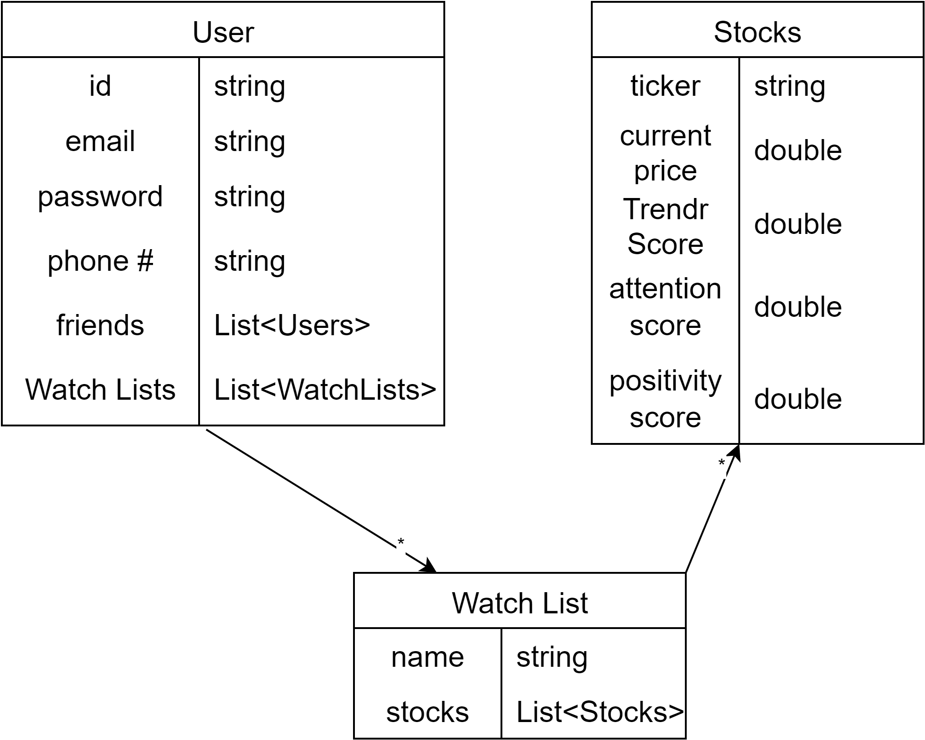](https://app.diagrams.net/?page-id=C5RBs43oDa-KdzZeNtuy&scale=auto#G16WvuZImR2TULQ4_rON_BRdRwHScYr7Fv)

Description of Classes and Class Interactions

1. User
   1. People who sign up and create an account are users.
   2. Users will give their email and phone number for two-factor authentication.
   3. Users will have a list of “friends” which is a list of other users that they follow.
   4. Users can create as many watchlists as they want.
2. Watch List
   1. Each watch list is given a name by the user that creates it.
   2. Watch lists are lists of stocks chosen by the user that created the watch list.
3. Stocks
   1. Each stock can be recognized by its unique ticker.
   2. Each stock has a price which is grabbed by the api.
   3. Each stock has a given Trendr score, calculated from the attention score and the positivity score.
   4. Each stock has an attention score calculated from social media activity.
   5. Each stock has a positivity score calculated by taking the if the stock is mentioned positively or negatively in its mentions

Flow Diagram

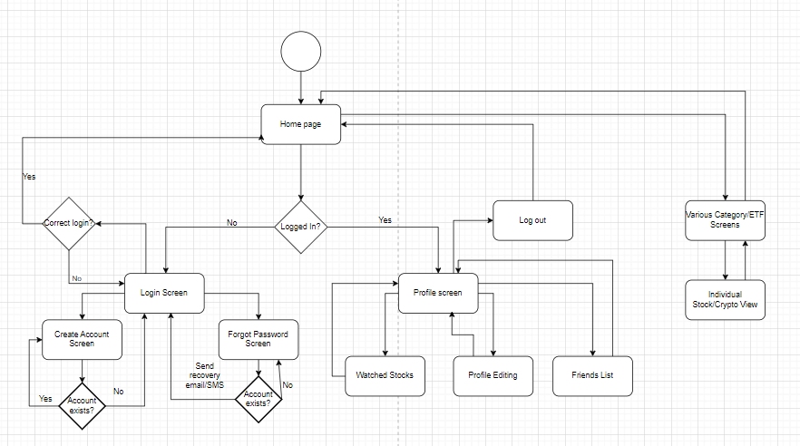

Brief Explanation of Flow Diagram

The user enters the website on the homepage which will greet the user with different tabs for stock categories, some top 10 movers/trendrs, and the ability to access a profile if you are logged in. When a user is logged in, they have access to account specific information such as watched stocks and a friends list. Users without an account can create one from the homepage, or they can reset the password of their existing account.

Sample view of an individual stock:

